**OPERATION DRIVE BY CONTENT SUBMISSION INSTRUCTIONS**

**PLEASE READ**

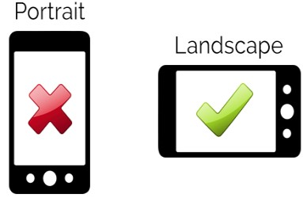**1. Customized Graphic for Occasion:** Customized graphic for occasion including the person’s name & picture will be created by LPMG, see examples below.

**2: Slide Show Presentation Creation:** We will create your slide show with the pictures that you submit. Please crop and edit all pictures before submitting. Slide show presentation will automatically include one background track.

**UP TO 50 PICTURES**

**3. Video Presentation:** A video presentation will be created including all the content submitted and the material will be played on driver & passenger sides of LED Billboard. Feel free to provide content from family and friends as well. **UP TO 25 VIDEOS** (We suggest recording videos in Landscape).

|  |
| --- |
| **VIA WHATS APP** |
| **CONTENT MUST BE SUBMITED 2 DAYS PRIOR TO**  **EVENT DATE**  UP TO 50 PICTURES & 25 VIDEOS  Please send all content to our WhatsApp number 305 974-4568 - Content cannot be sent on multiple dates and must be sent from the same phone number not multiple phone numbers.  Icon  Description automatically generated |

**BEFORE SENDING CONTENT, PLEASE SEND YOUR INVOICE # - ALL CONTENT MUST BE SENT THREE DAYS PRIOR TO EVENT DATE.**

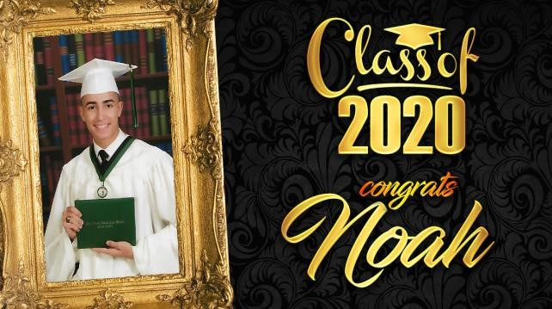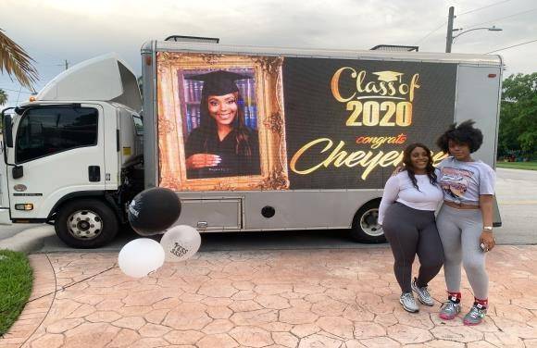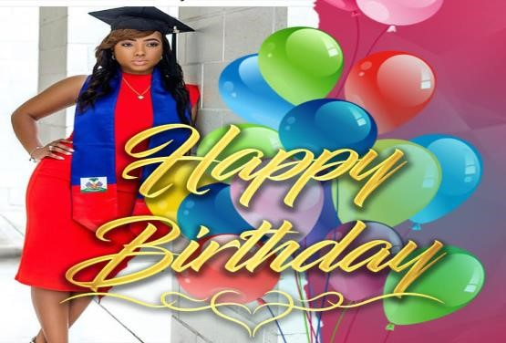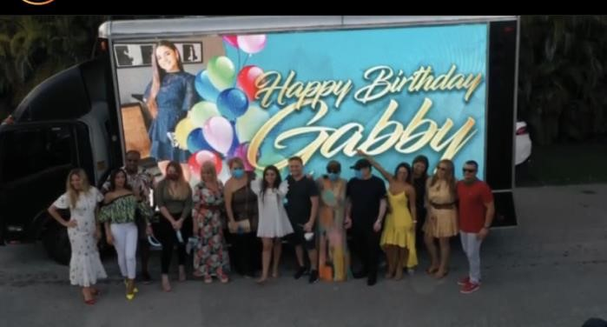

**Day of your booking:** Driver/Dispatch will contact client when five minutes from address listed on submission form. At this time client may provide any additional information (Ex. surprise, gate code, point of entry, or how to proceed). Presentation will include customized graphic, followed by slide show, followed by video presentation, then back to customized graphic.